ERRATA AULA 05 Slide 16
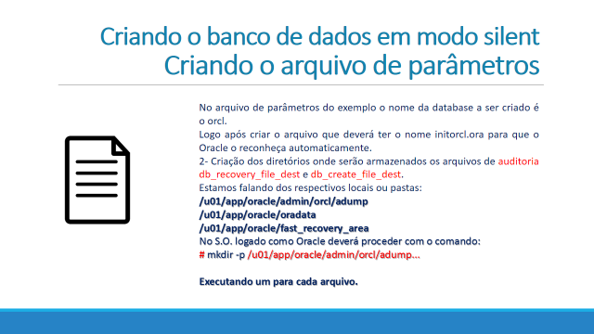
Onde está:
/u01/app/oracle/oradata/fast_recovery_area
Leia-se:
/u01/app/oracle/fast_recovery_area

